**BigID Home Assignment**

-Yeshwanthan A

GitURL: https://github.com/Yeshwanthan87/homeassignment.git

Writing app.py

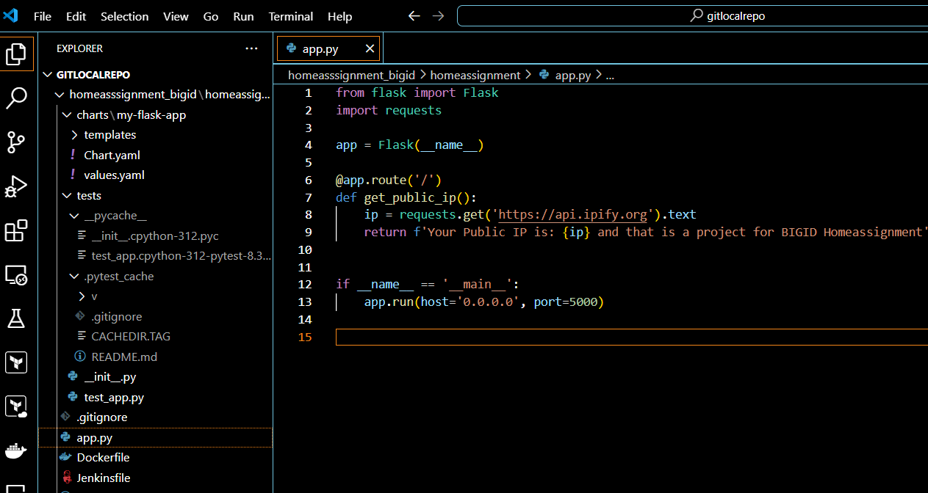

Writing test case:



Writing Helm charts:

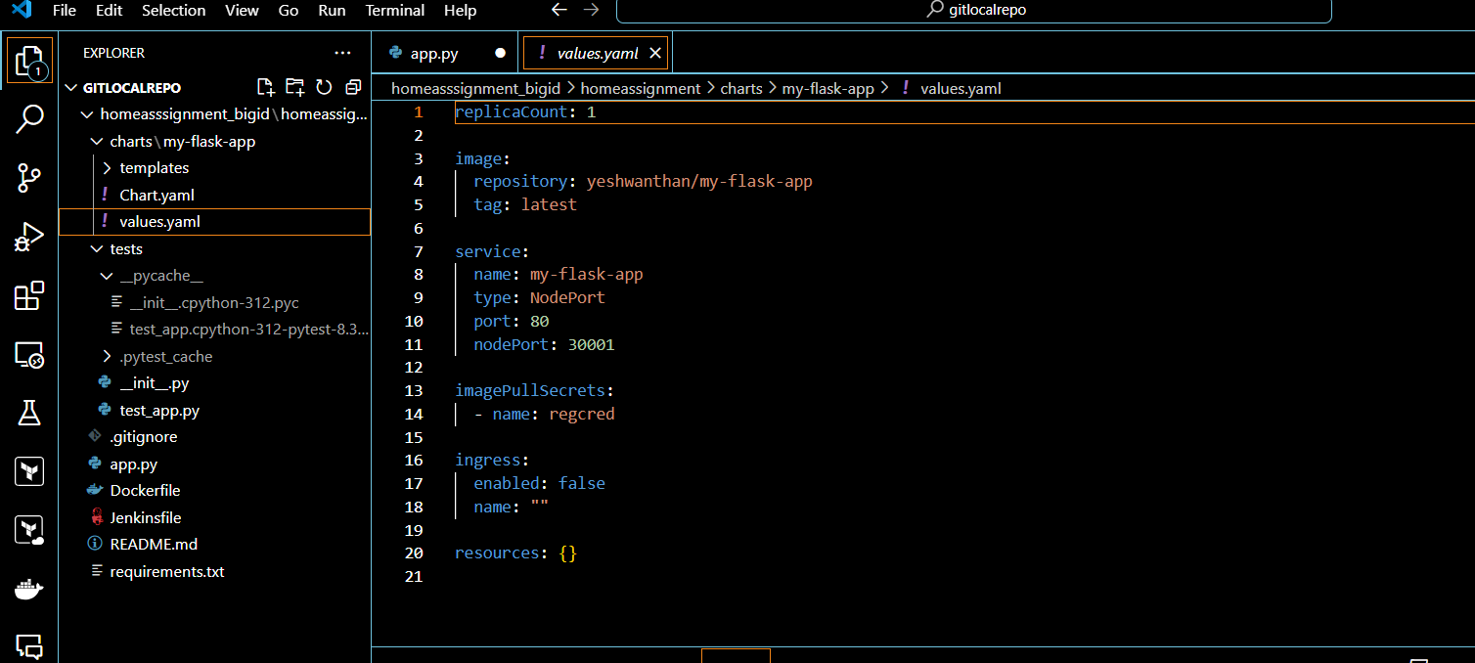

Writing Docker file:

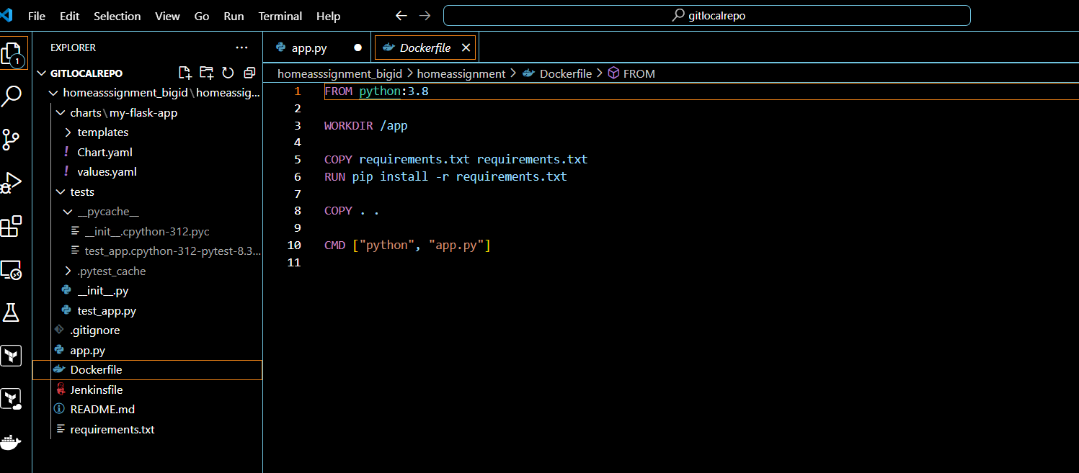

Writing Jenkins file:

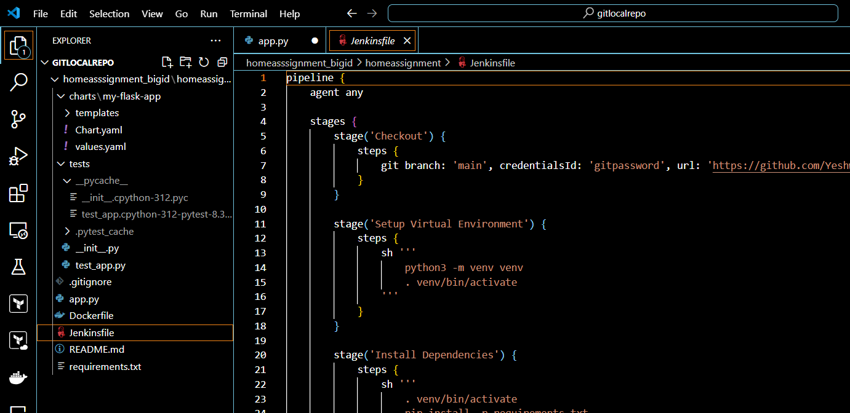

Creating VPC in AWS

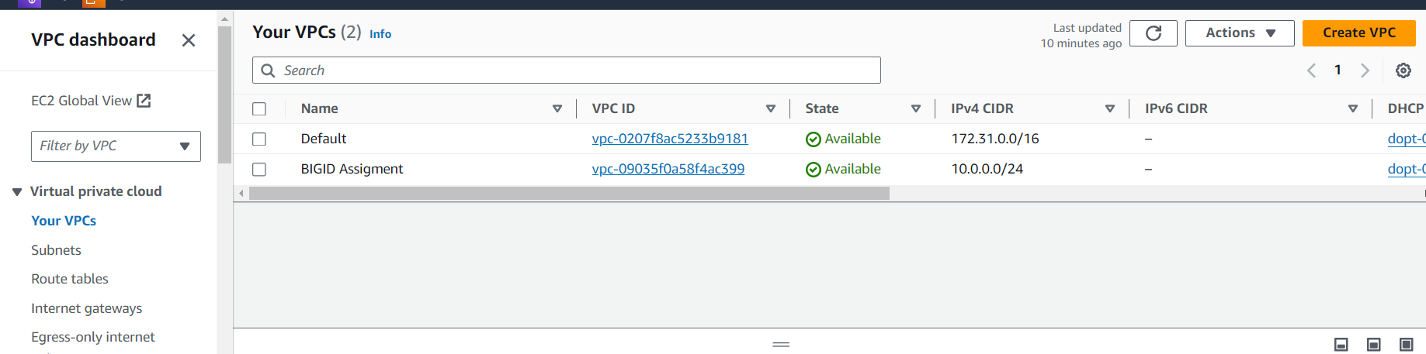

Creating Subnets

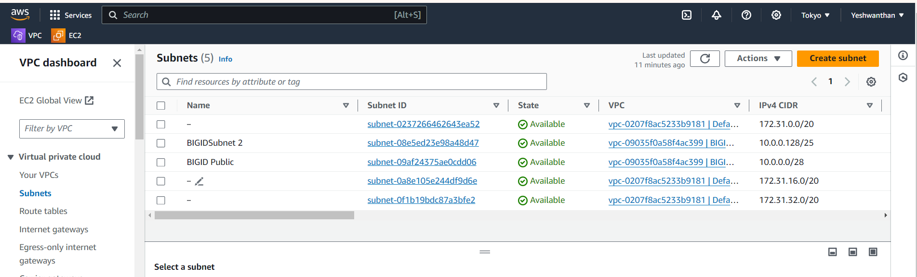

Creating Security Groups

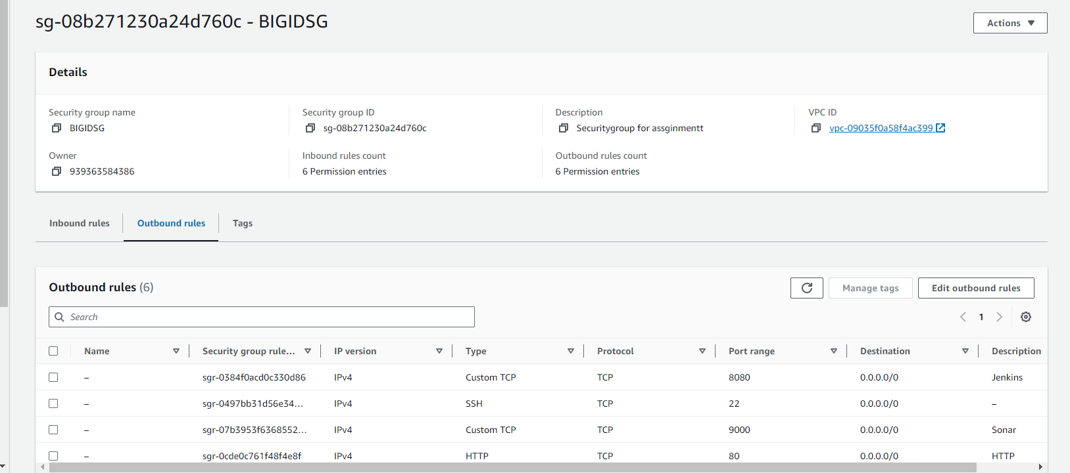

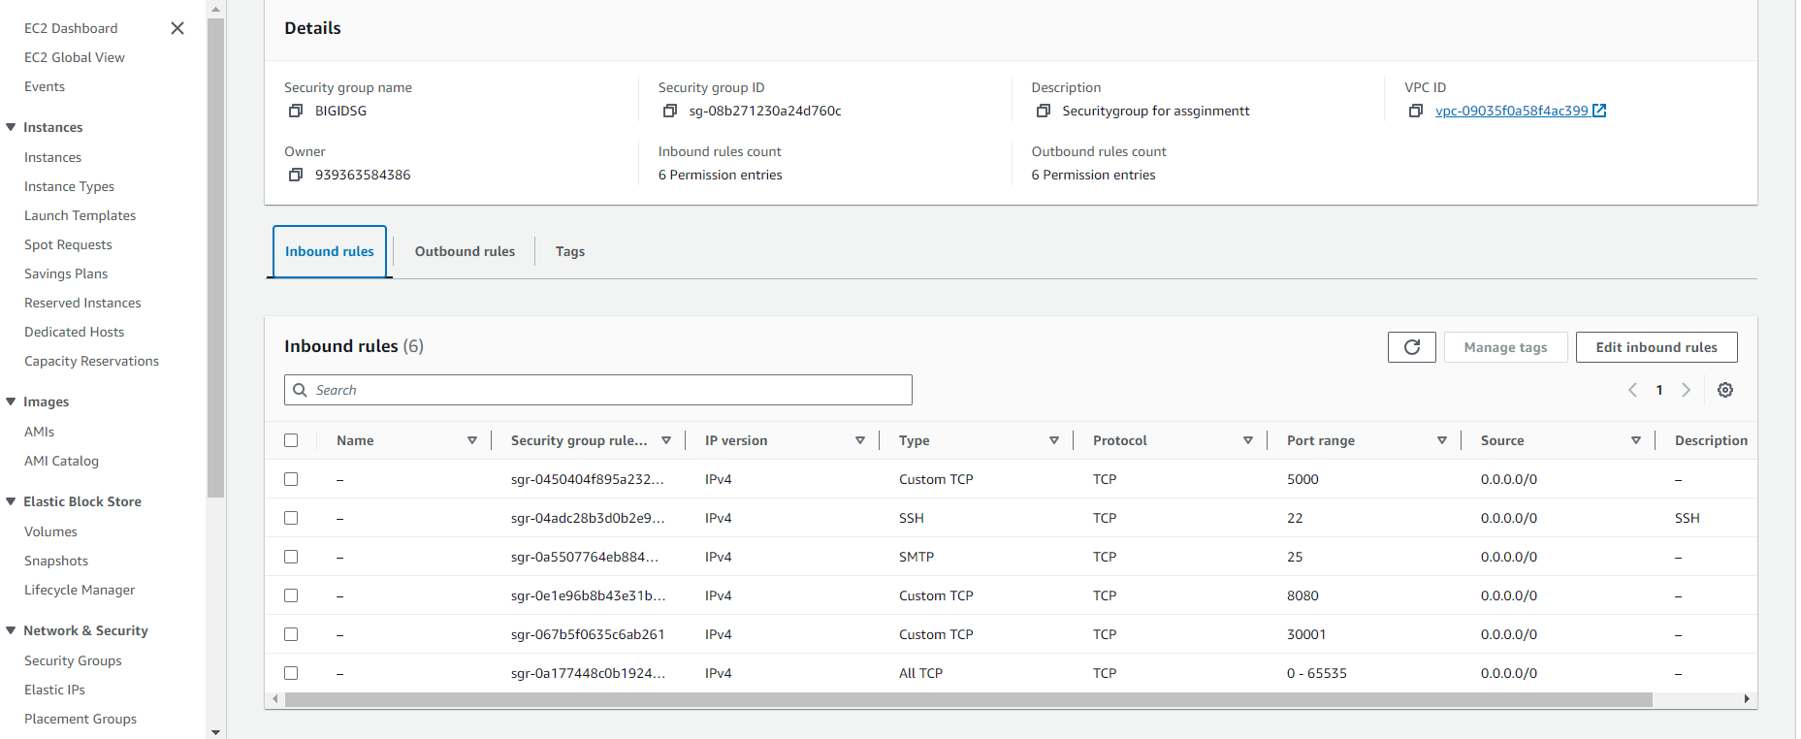

EC2

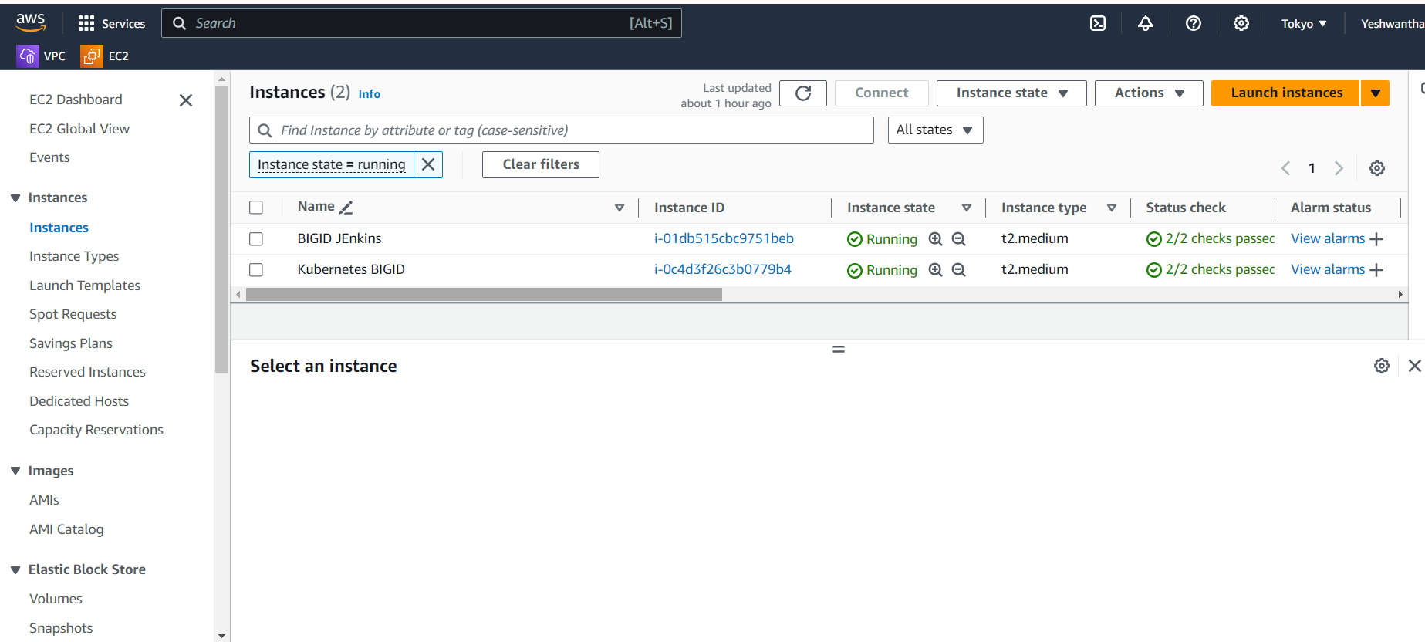

Logging in ec2 and installing Jenkins and Docker

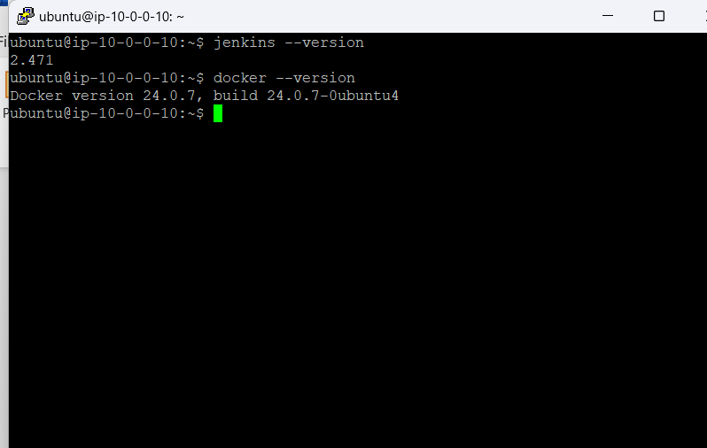

Logging in Kubernetes BIGID and installing miniqube, docker, Helm

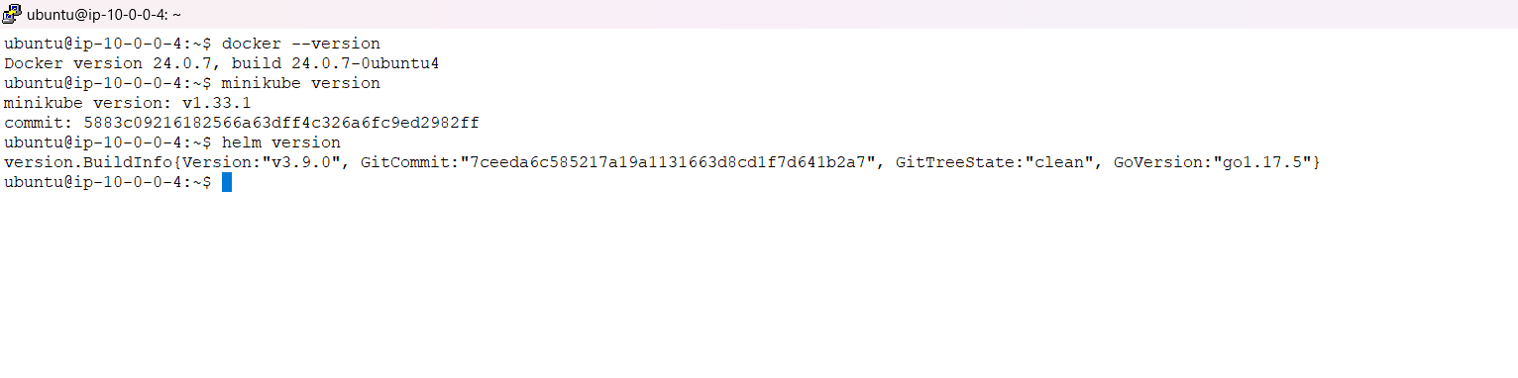

Placing helm charts in miniqube Kubernetes

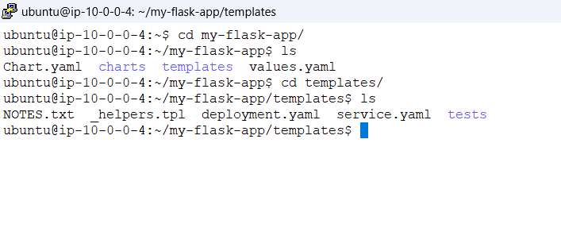

Creating SSH connecting between the EC2 machines

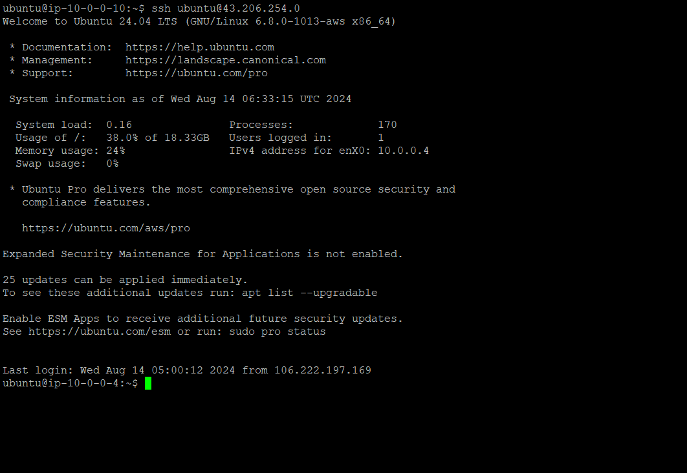

Configure Jenkins and install Plugins

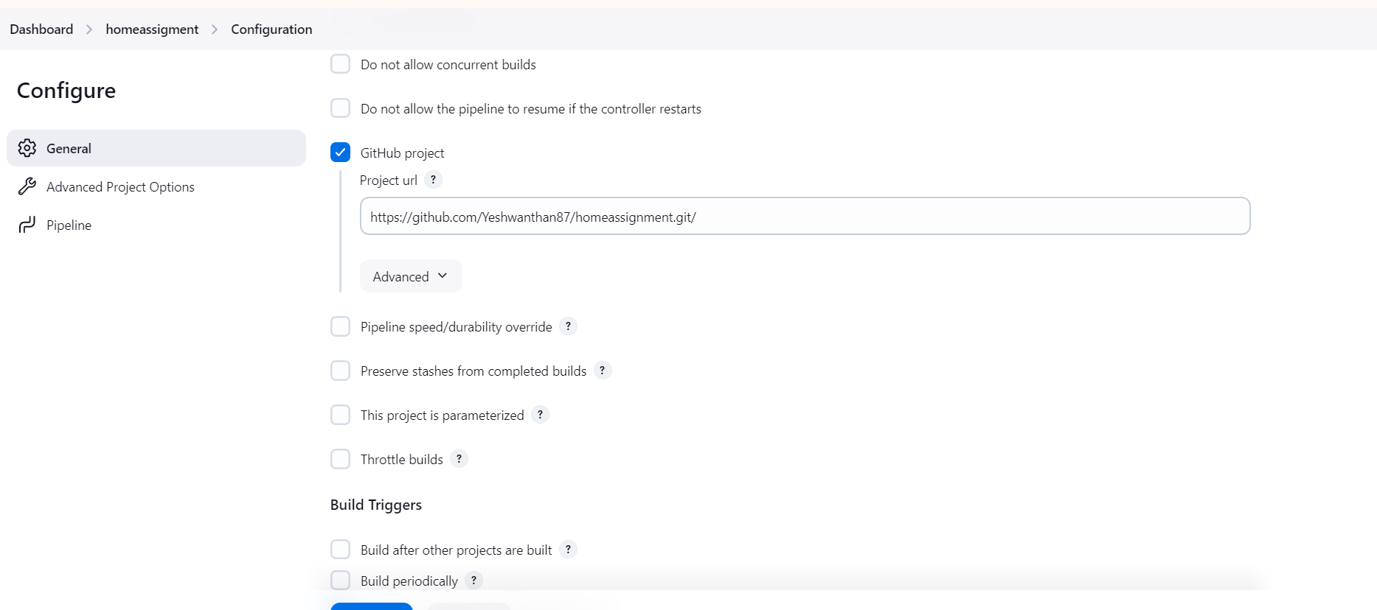



Check and push the code to git repo:

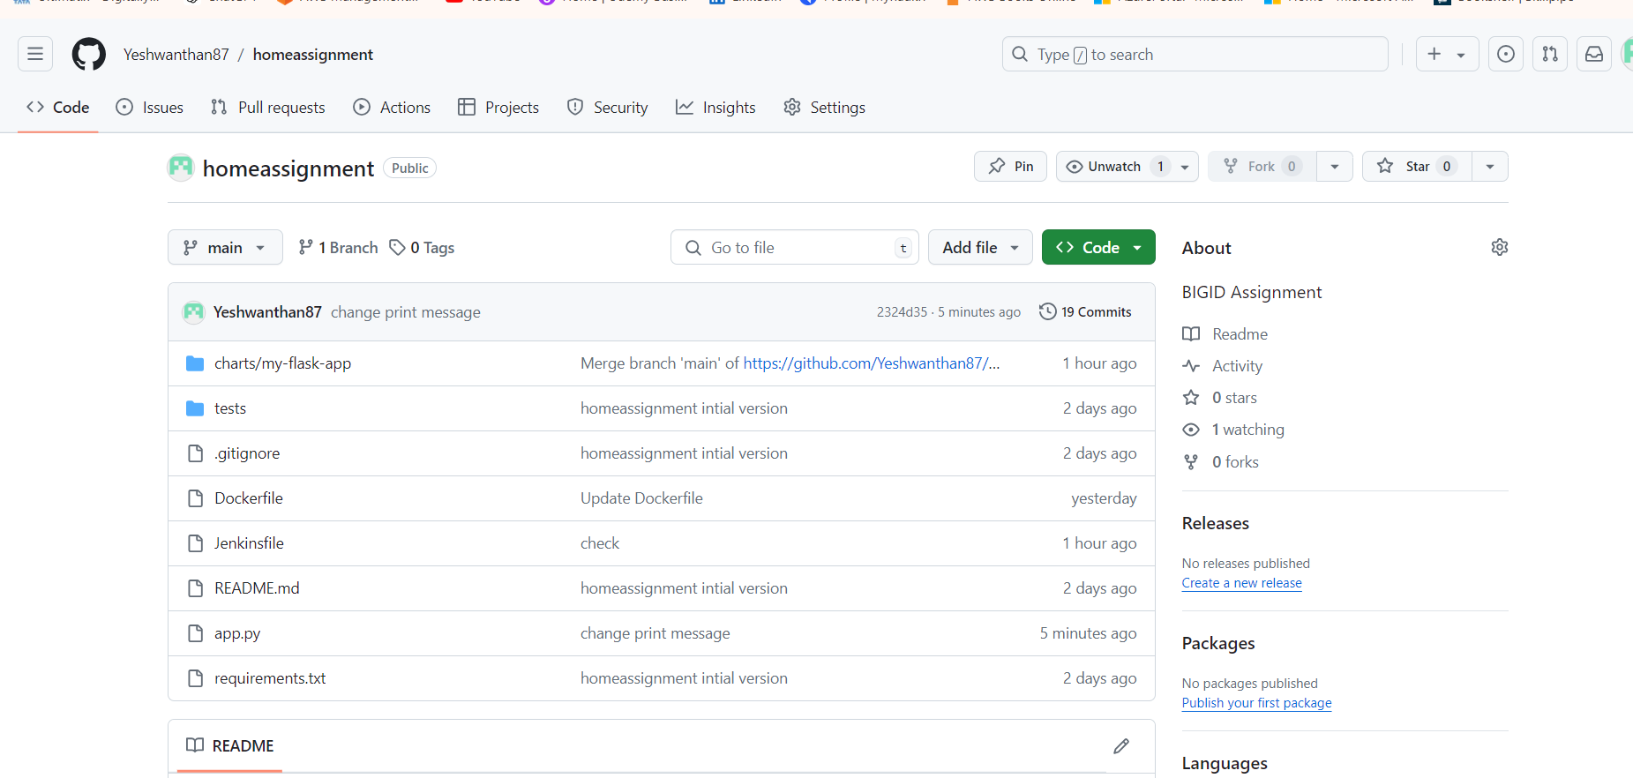

Check the Jenkins run stages:

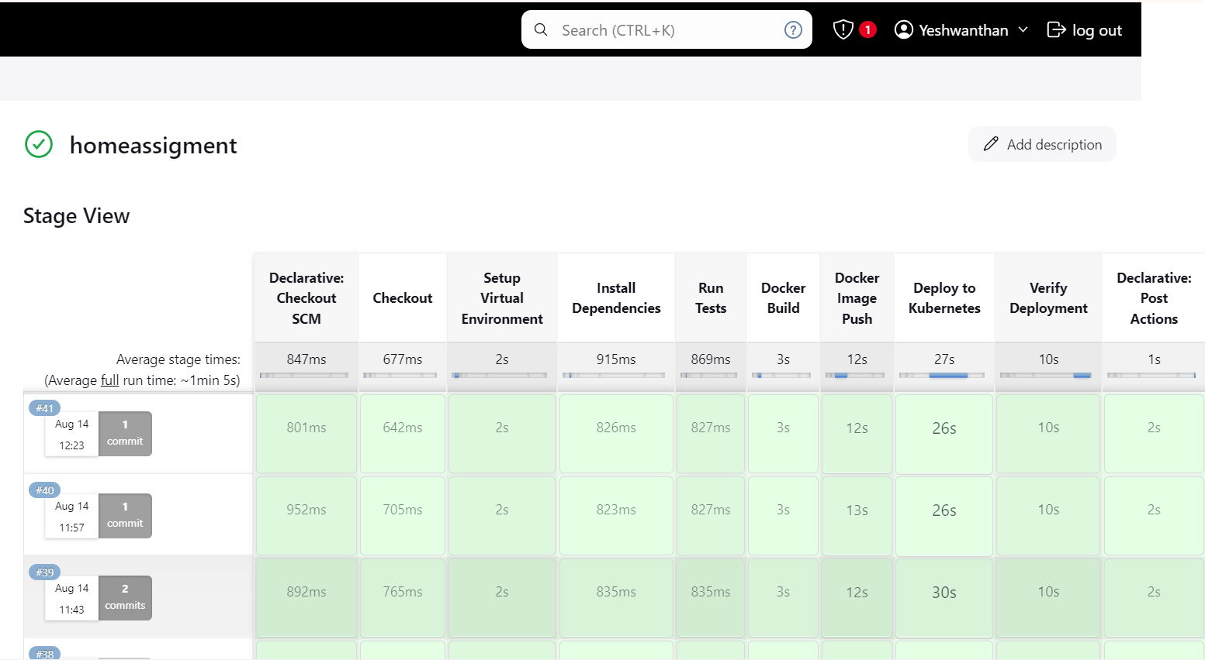

Check for untitest cases passed:

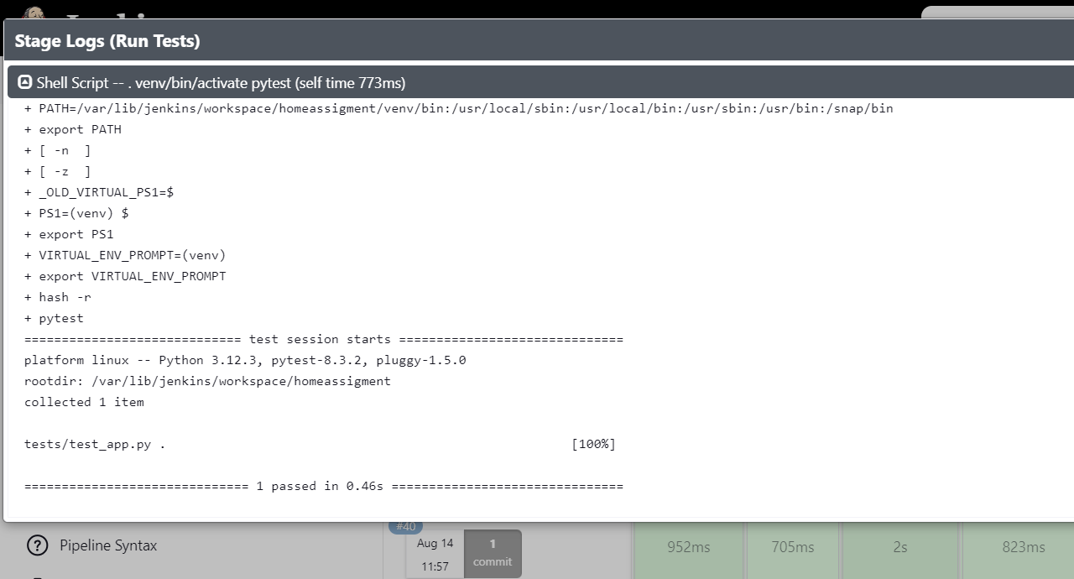

Check the docker hub for image pushed:

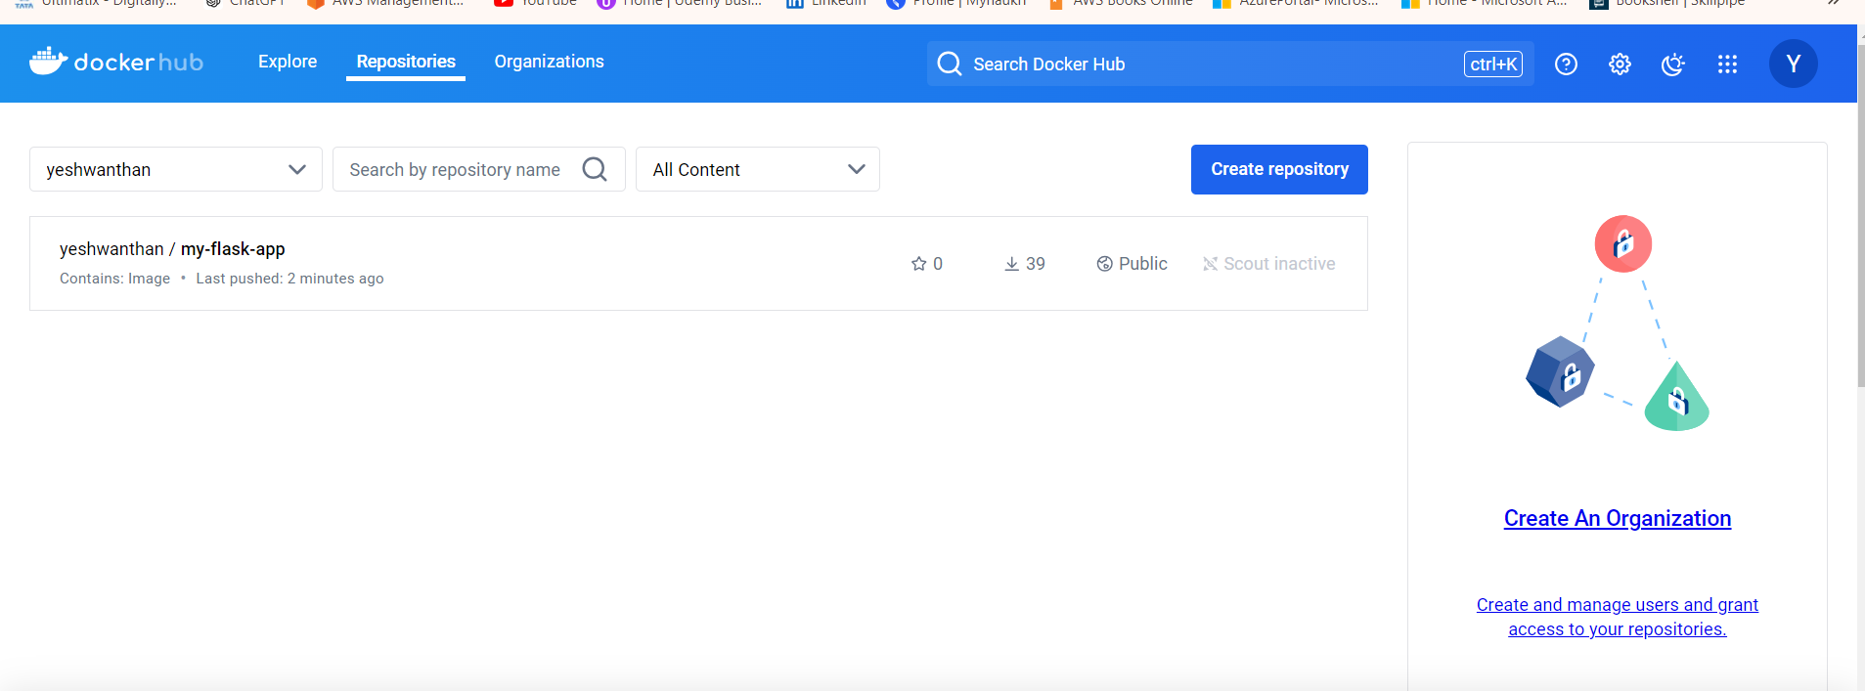

Check for Deployment stage status in Jenkins pipeline

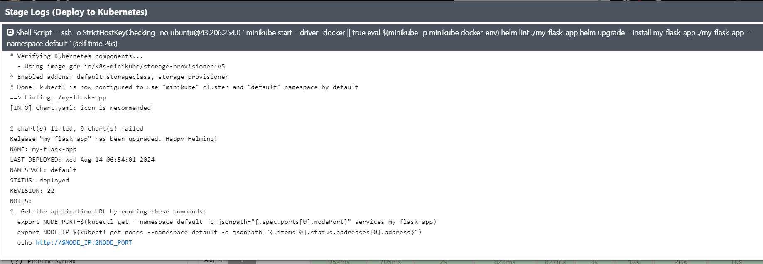

Check for Pod status

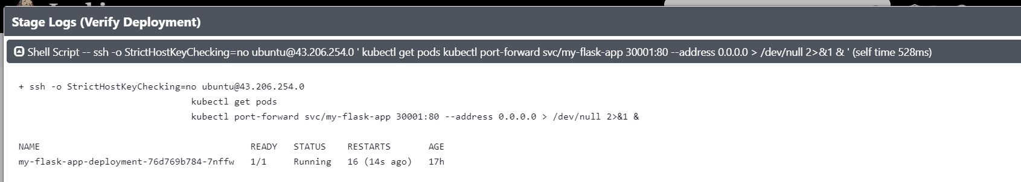

Check for email for post actions for pipeline stage:

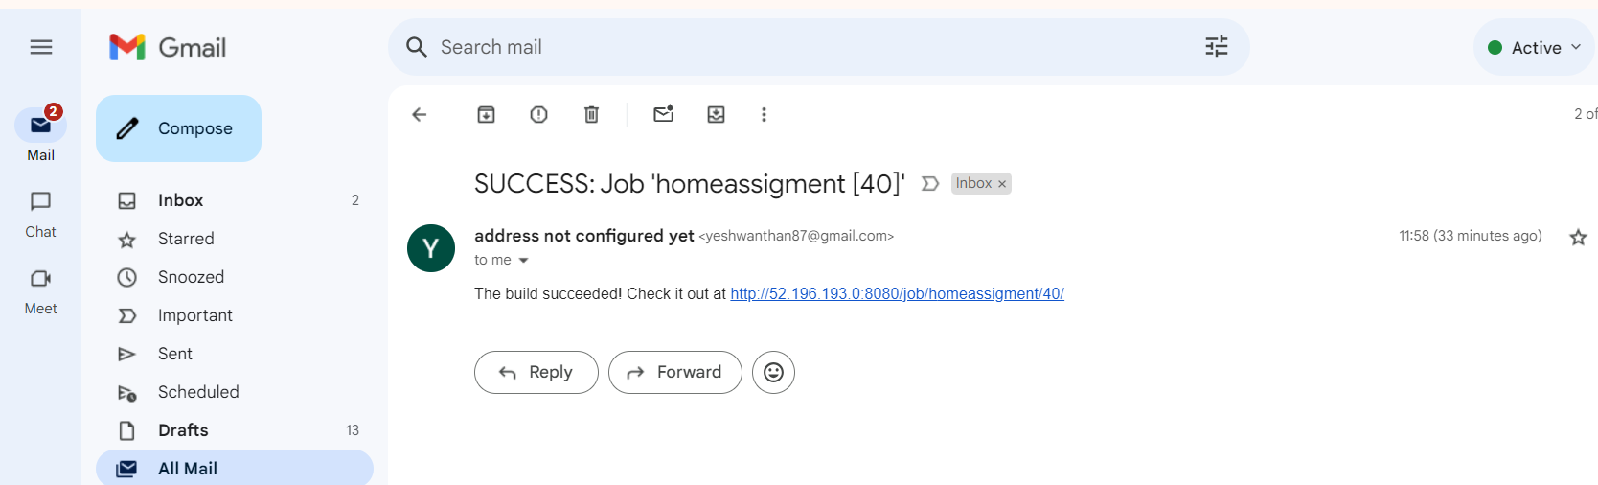

Finally, Check for the application deployed: